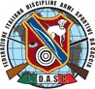



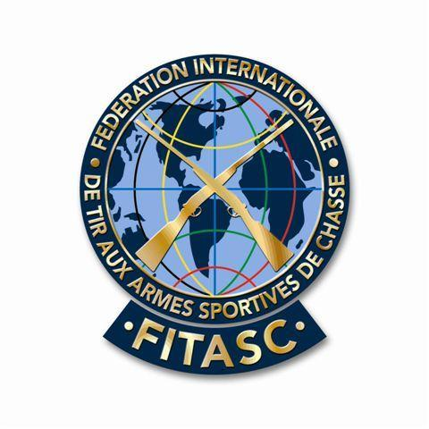
Federazione Italiana Discipline Armi Sportive Da Caccia
Federazione Sportiva riconosciuta dal C.O.N.I.
V.le Tiziano, 70 – 00196 Roma – Tel. 06.36858162/489 – Fax 06.36858128 – C.F. 97175110580
E-mail: segreteria@fidasc.it - Sito: www.fidasc.it
Fédération Internazionale
De Tir aux Armes Sportives
De Chasse
Consejo Mundial
De Federaciones Deportivas
De Caza y Tiro

The President

COMBINED GAME SHOOTING
TAV VALLE DUPPO SHOOTING RANGE
LODRINO (BRESCIA) – ITALY
21st – 22nd JUNE 2008

INVITATION

Dear friends,

F.I.D.A.S.C., Federazione Italiana Discipline Armi Sportive da Caccia cordially invite you to participate at the Combined Game Shooting which will take place from 21st to 22nd june 2008 at the TAV Valle Duppo Shooting Range in Lodrino – Brescia - Italy.

Yours sincerely,

Felice Aniello Buglione
Fidasc President

